H.T No
Regulations:
A17

Sreenidhi Institute of Science and Technology
(An Autonomous Institution)
Code No: 6AC41 Date: 02-Jan-2023 (FN)

B.Tech II-Year II- Semester (A18) Special Supplementary Examination - December-2022
Elements of Electrical Engineering (CSE and IT)

Time: 3 Hours Max.Marks:75

Note: a) No additional answer sheets will be provided.
b) All sub-parts of a question must be answered at one place only, otherwise it will not be valued.
c) Missing data can be assumed suitably.

ANSWER ANY 5 OUT OF 8 QUESTIONS. EACH QUESTION CARRIES 15 MARKS.

Bloom's Cognitive Levels of Learning (BCLL)

Remember | L1 | Apply | L3 | Evaluate | L5
Understand | L2 | Analyze | L4 | Create | L6

 |  |  | BCLL | CO(s) | Marks
1. | a) | Using Thevenin’s theorem calculate the current I through the resistance connected between the terminal A & B (All resistances are in ohms). As shown in below figure.  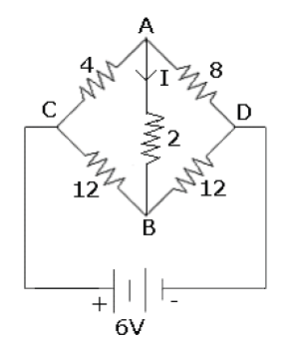 | L3 | CO1 | [8M]
 | b) | Distinguish between ideal and practical voltage source. | L2 | CO1 | [7M]
2. | a) | Find the equivalent impedance of the circuit if the circuit is operating at 5rad/sec.  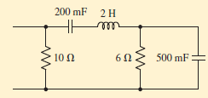 | L5 | CO2 | [8M]
 | b) | The field winding of a D.C electromagnet is wound with 960 turns and has resistance of 50Ω when the exciting voltage is 230V, the magnetic flux linking the coil is.005Wb. Calculate the self-inductance of the coil and the energy stored in the magnetic field. | L4 | CO2 | [7M]
3. | a) | Derive the expression of induced EMF of DC generator. | L2 | CO3 | [8M]
 | b) | An 8-pole lap wound DC generator has 960 conductors, a flux of 40mWb per pole. and is driven at 400 rpm. Find induced EMF. | L4 | CO3 | [7M]
4. | a) | What is OC and SC test? Why is it conducted on transformers? | L2 | CO4 | [8M]
 | b) | A transformer has a primary winding of 800 turns and a secondary winding of 200 turns. When the load current on the secondary is 80A at 0.8 p.f lagging, the primary current is 25A at 0.707 power factor lagging. Determine graphically the no-load current of the transformer and its phase with respect to voltage. | L3 | CO4 | [7M]
5. | a) | How is a rotating magnetic field produced in a 3-ϕ induction motor? Explain in detail with relevant phasors. | L2 | CO5 | [8M]
 | b) | Give in detail the operating principle of a 3-ϕ induction motor. | L1 | CO5 | [7M]
6. | a) | How will use a P.M.M.C instrument which gives FSD at 50mv P.D and 10mA current as Voltmeter (0-250V) range and an ammeter of 0-10A range? | L2 | CO6 | [8M]
 | b) | A moving coil milli ammeter has a resistance of 5Ω and a full-scale deflection of 20mA. Determine the resistance of a shunt to be used so that the instrument could measure currents upto 500mA at 20ºC . What is the % error in the instrument operating at a temperature of 40ºC ? Temperature co-efficient of copper=0.0039 per ºC. | L4 | CO6 | [7M]
7. | a) | Write down KVL and KCL in point form. | L1 | CO1 | [5M]
 | b) | Find the average and RMS values of the saw tooth wave form shown in below Figure.  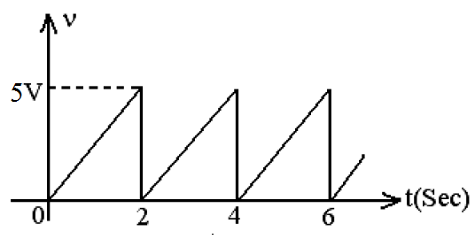 | L3 | CO2 | [5M]
 | c) | Derive condition for maximum efficiency of D.C. Generator. | L3 | CO3 | [5M]
8. | a) | Draw the no-load diagram of a single-phase transformer and why the transformer core is laminated. | L1 | CO4 | [5M]
 | b) | Derive the expression for maximum torque in a 3-ϕ induction motor and what is the slip corresponding to maximum torque | L3 | CO5 | [5M]
 | c) | Explain the essential features of Indicating instruments | L2 | CO6 | [5M]

-- 00 -- 00 –

